DevelopersHub Corporation
Software Quality Assurance (SQA) – 6 Weeks Project
Week 6 – CI/CD QA + Final QA Portfolio
Student Name: Anam Saghir
Submission Date: 14 April 2026
GitHub Final QA Portfolio Repo Link:
https://github.com/anam125/QA-Portfolio

Week 6 – CI/CD QA + Final QA Portfolio Compilation

Objective:
The objective of this task is to understand how Quality Assurance (QA) integrates into CI/CD (Continuous Integration and Continuous Deployment) pipelines and to create a complete professional QA portfolio. This includes documentation, testing reports, and understanding automation integration within modern software development practices.

Learning Focus
- Introduction to CI/CD for QA
- Test Automation Integration
- Git and GitHub usage for QA
- Preparation of a complete QA Portfolio

Task 1: Learn CI/CD Basics for QA
Introduction to CI/CD
CI/CD stands for:
- Continuous Integration (CI):
Developers frequently integrate code into a shared repository where automated tests are executed.
- Continuous Deployment (CD):
After successful testing, the code is automatically deployed to production.
In simple terms:
Code change → Automatic testing → Automatic deployment

Role of QA in CI/CD
QA plays a critical role in ensuring software quality throughout the pipeline.
1. Automated Testing in Pipelines
- QA engineers create automation scripts (e.g., Selenium)
- These scripts run automatically whenever new code is pushed
- Helps detect bugs early

2. Continuous Feedback
- If a test fails, the system immediately notifies developers
- Enables faster debugging and fixing

3. Quality Gate
- Deployment only happens if all test cases pass
- Prevents faulty code from reaching production

CI/CD Tools Overview
Jenkins
- Open-source automation server
- Used for building, testing, and deploying applications
GitHub Actions
- Built-in CI/CD tool in GitHub
- Automates workflows directly from repository

Screenshot:
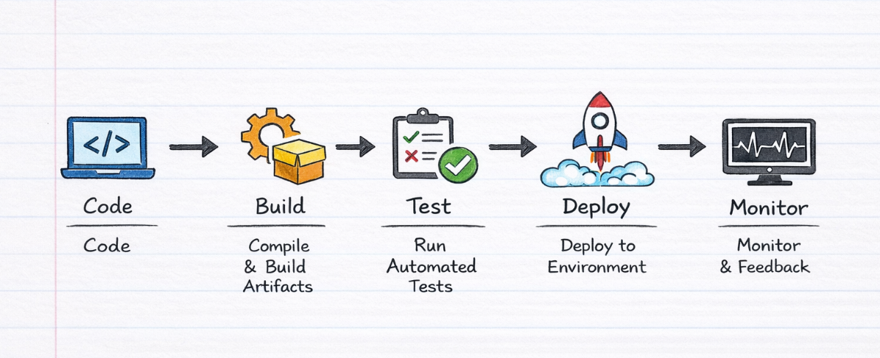
- CI/CD pipeline diagram

Task 2: Create a GitHub Repository
Objective
To store QA documents, reports, and automation scripts in a structured and professional way under each week’s headings all are given in a proper documented format.

Step-by-Step Procedure
Step 1: Create Repository
- Go to GitHub
- Click on “+” → New Repository
- Enter details:
  - Repository Name: QA-Portfolio
  - Description: My SQA Tasks and QA Portfolio
- Select Public
- Click Create Repository

Screenshot Placeholder:
- Repository creation page
- Created repository homepage
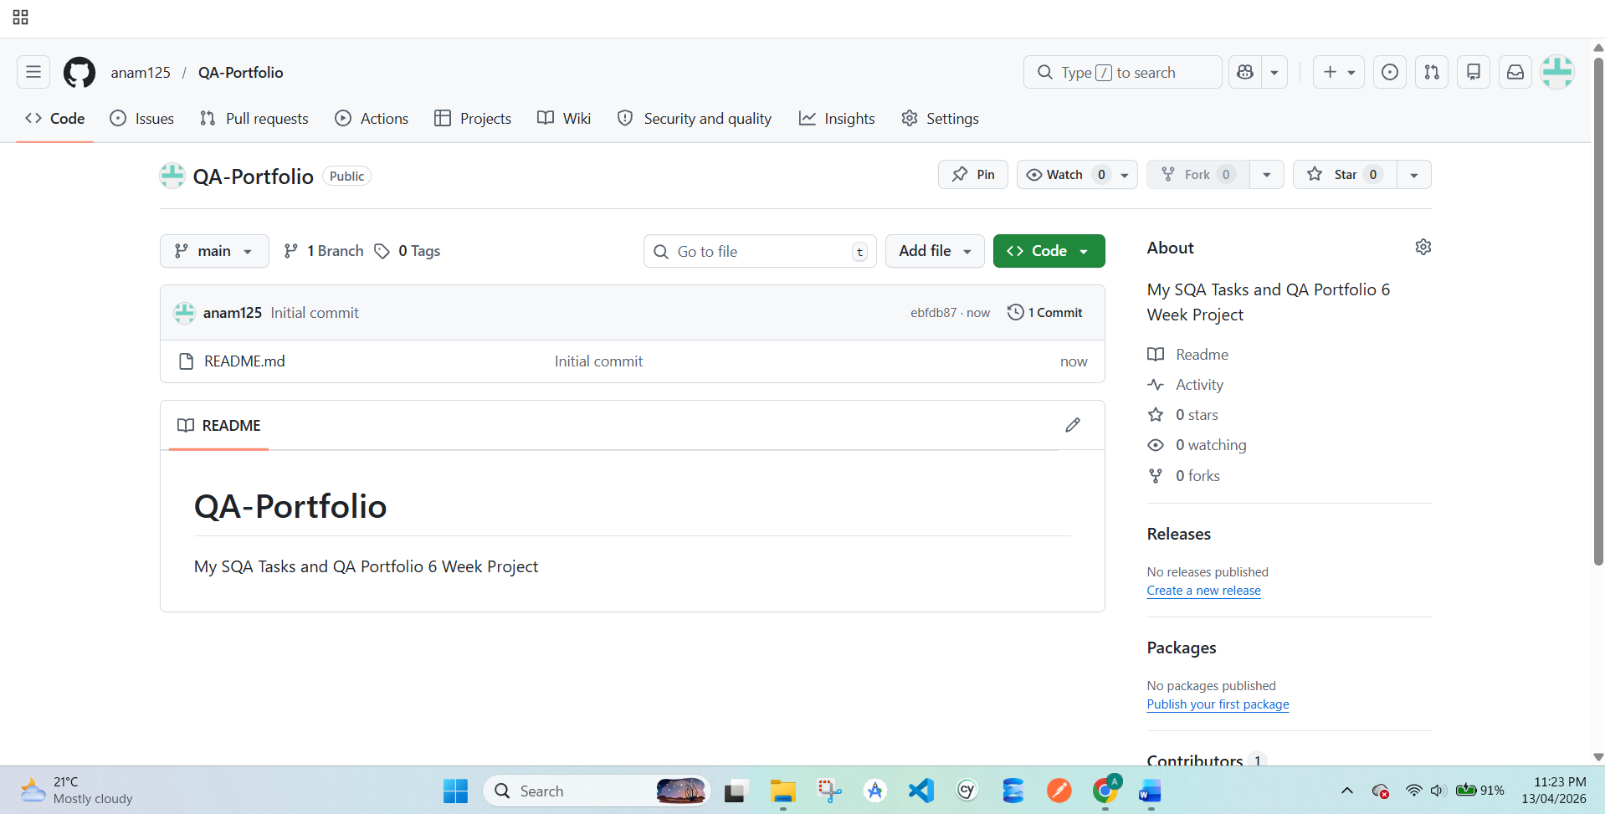

Step 2: Create Week-wise Folders
Create folders for better organization:
- Week-1
- Week-2
- Week-3
- Week-4
- Week-5
- Week-6

Screenshot Placeholder:
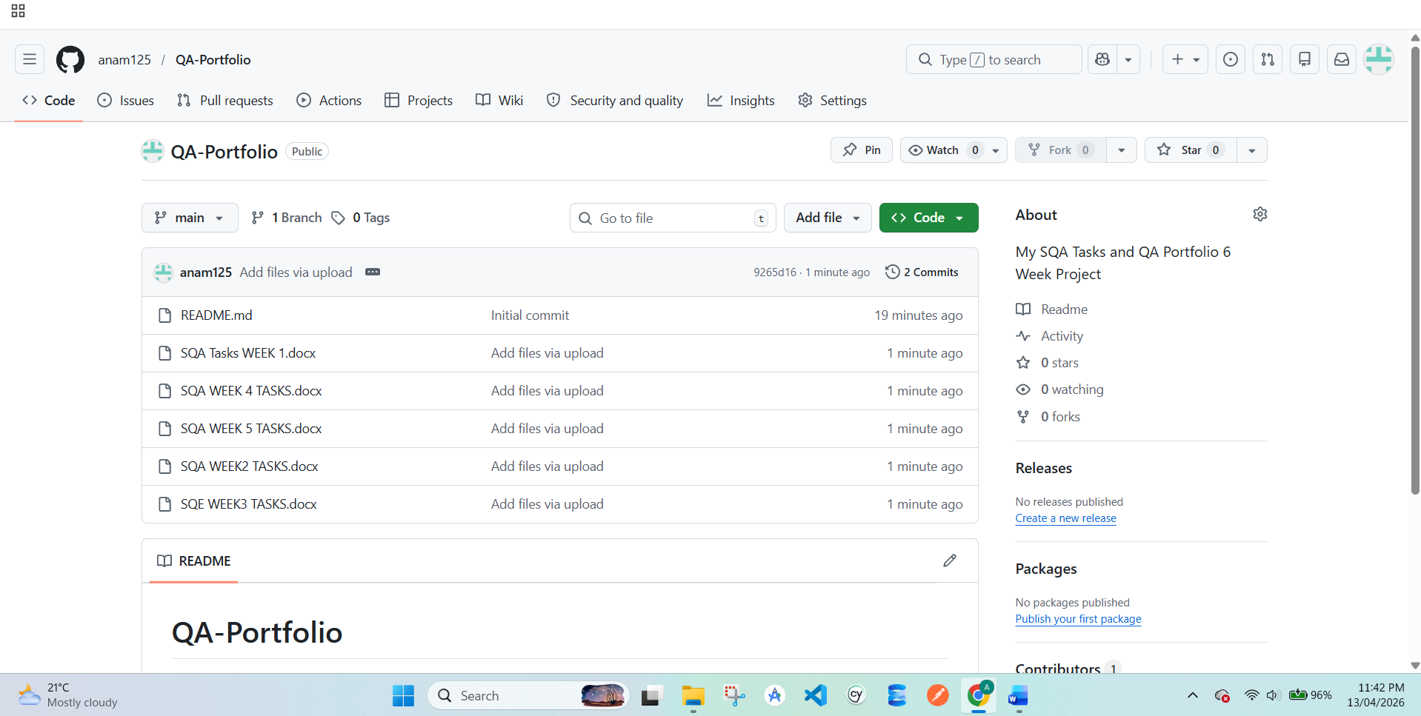
- All folders inside repository

Step 3: Upload Files
Upload your documents:
- Test Cases
- Test Plan
- Bug Reports
- Performance Testing Report
- Security Testing Report
- Week-wise PDFs

Step 4: Add README File
Create a README file describing your portfolio.

README Content:
# QA Portfolio – Anam Saghir

## Introduction
This repository contains my complete Software Quality Assurance work from Week 1 to Week 6.

## Contents
- Test Cases
- Test Plan
- Bug Reports
- Performance Testing Report
- Security Testing Report
- CI/CD Workflow

## Tools Used
- Selenium
- Apache JMeter
- OWASP ZAP
- GitHub

## Objective
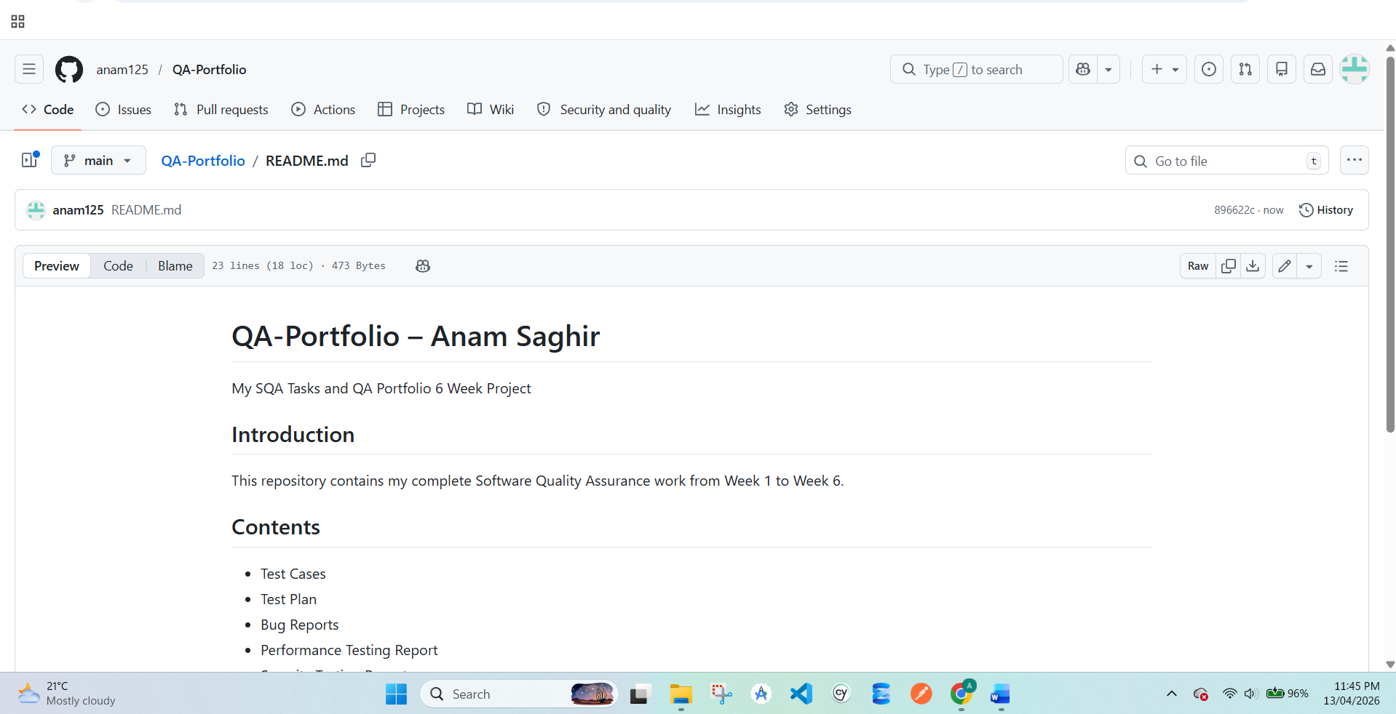
To demonstrate QA skills including manual testing, automation, and CI/CD integration.
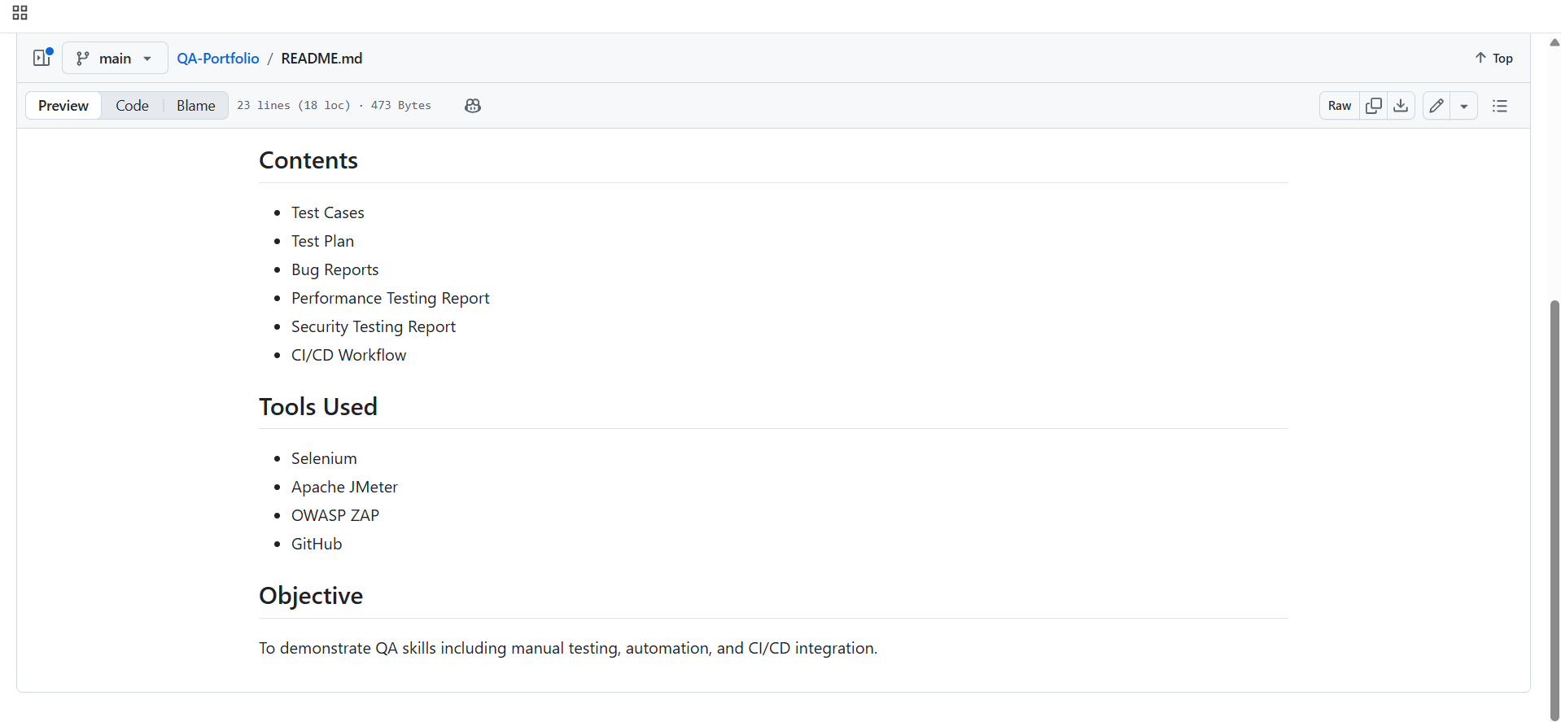
Task 3: CI/CD Workflow (Theory Only)
Objective
To understand how automation testing integrates into CI/CD pipelines.

Workflow Explanation
- Developer pushes code to repository
- CI/CD pipeline is triggered automatically
- Selenium test scripts are executed
- Test results are generated
- If tests pass → application is deployed
- If tests fail → developer fixes errors

Trigger Events
Tests can be triggered by:
- Code push
- Pull request
- Scheduled execution

Test Report Generation
- Reports are automatically generated after execution
- Includes:
  - Passed test cases
  - Failed test cases
  - Error logs
  - Screenshots (if configured)

Sample CI/CD Workflow (Theory)
Step 1: Developer pushes code to GitHub
Step 2: GitHub Actions workflow starts
Step 3: Selenium test cases run automatically
Step 4: Test results generated
Step 5: If success → Deploy
Step 6: If failure → Notify developer

Task 4: Final QA Portfolio Document
Objective
To compile all QA work into a professional document.

1. Test Cases Summary
Include:
- Test Case ID
- Description
- Expected Result
- Actual Result
- Status
2. Test Planning
Testing strategy and tools are selected.
For this project:
Test Case Tool → Google Sheets
Bug Tracking Tool → Jira

3. Test Case Development
Test cases are written for each feature.
Each test case contains:
- Test ID
- Test Description
- Preconditions
- Test Steps
- Expected Result
- Actual Result
- Status

4. Test Execution
Test cases are executed on the application.
Results are recorded as:
Pass / Fail.

2.Bug Reporting
If a test fails, it is recorded as a bug.
Bug reports include:
- Bug ID
- Description
- Severity
- Priority
- Steps to reproduce
- Status

. Test Closure
Testing results are summarized in a report.

5. Manual Testing Process for SweetNSwirls
The following modules were selected for testing:
- Signup
- Login
- Dessert Menu
- Add to Cart
- Cart Management
- Checkout and Order Placement

6. Writing Test Cases using Google Sheets:
Test cases were created using Google Sheets.
Steps to create test cases:
- Open Google Sheets
- Create a new sheet
- Create the following columns:
| Test ID | Test Description | Preconditions | Test Steps | Expected Result | Actual Result | Status |
Example Test Cases
Test ID | Test Description | Preconditions | Test Steps | Expected Result | Actual Result | Status
TC-01 | Verify signup with valid details | Signup screen open | Enter valid details and click signup | Account created successfully | Account created | Pass
TC-02 | Verify signup with empty fields | Signup screen open | Leave fields empty and click signup | Validation message should appear | No validation message | Fail
TC-03 | Verify login with valid credentials | Account exists | Enter correct email and password | User logged in | Login successful | Pass
TC-04 | Verify login with wrong password | Account exists | Enter wrong password | Error message should appear | No error message | Fail
TC-05 | Verify dessert menu display | User logged in | Navigate to menu screen | Desserts displayed correctly | Menu visible | Pass
TC-06 | Verify add to cart | Menu screen open | Select item and click add to cart | Item added to cart | Item added | Pass
TC-07 | Verify remove cart item | Cart contains items | Click remove button | Item removed | Item removed | Pass
TC-08 | Verify checkout process | Cart contains items | Click checkout | Order confirmation screen appears | Order confirmed | Pass

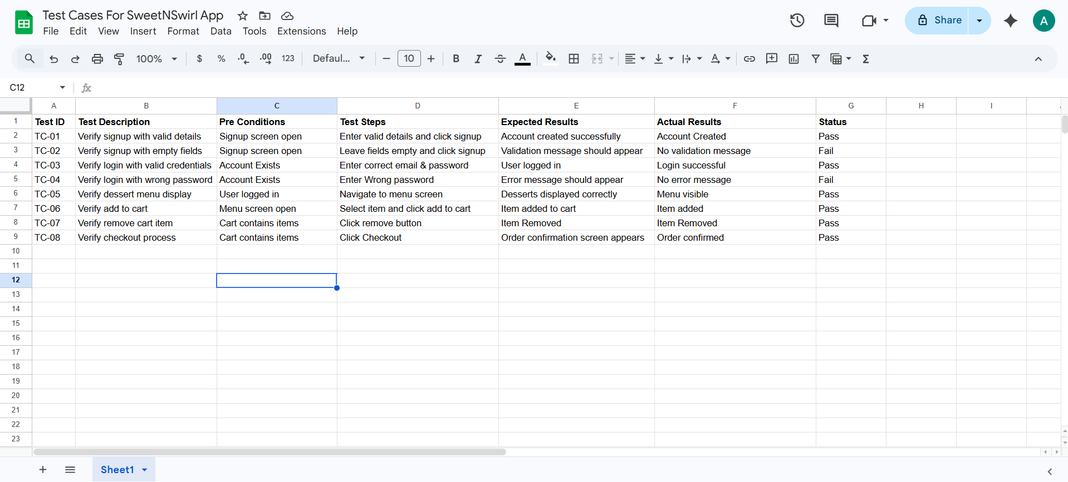
Screenshot Section:

7. Bug Reporting using Jira
Bug tracking was performed using
Jira.
Jira is a professional tool used by software companies to track software issues.

Steps to Create Bug Reports in Jira
- Open Jira website
- Create a new project
- Select Bug Tracking Template
- Click Create Issue
- Select Bug Issue Type
- Fill the bug details

Bug Report Fields in Jira
Each bug report includes:
- Bug ID
- Summary
- Description
- Severity
- Priority
- Steps to reproduce
- Status

Example Bug Reports
Bug ID | Description | Severity | Priority | Steps to Reproduce | Status
BUG-01 | Signup allows empty fields | High | High | Open signup → leave fields empty → click signup | Open
BUG-02 | Login does not show error for wrong password | Medium | High | Enter wrong password → click login | Open
BUG-03 | Cart icon does not update item count | Medium | Medium | Add item to cart | Open
BUG-04 | Checkout button alignment issue | Low | Low | Open cart screen | Open
BUG-05 | Menu images load slowly | Low | Low | Open menu screen | Open

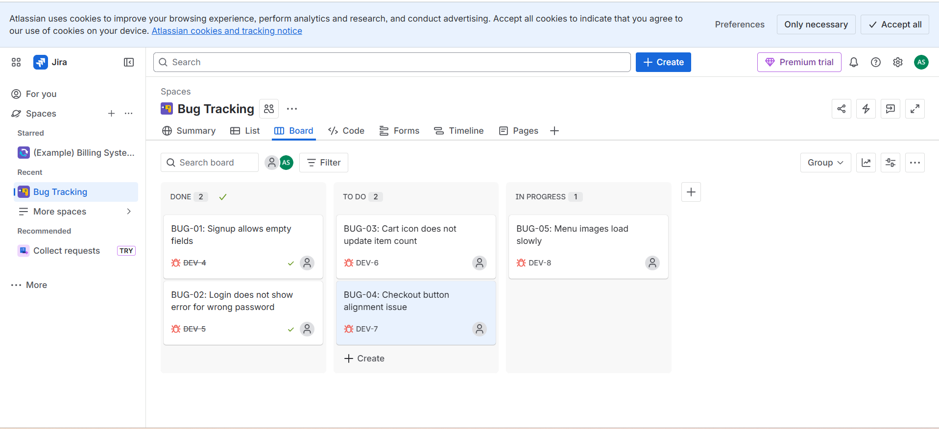
Screenshot Section:

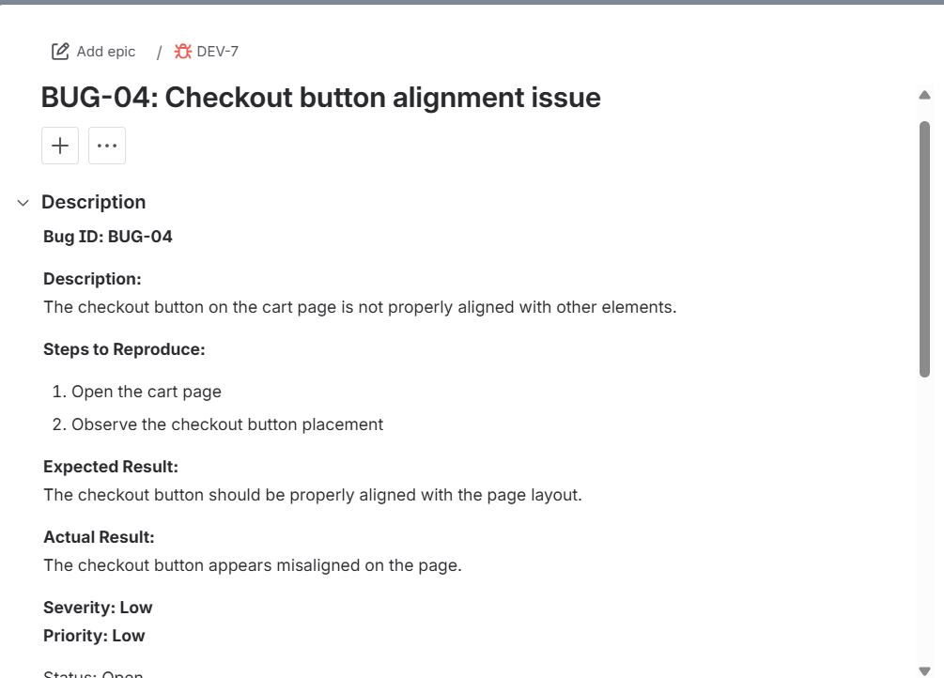

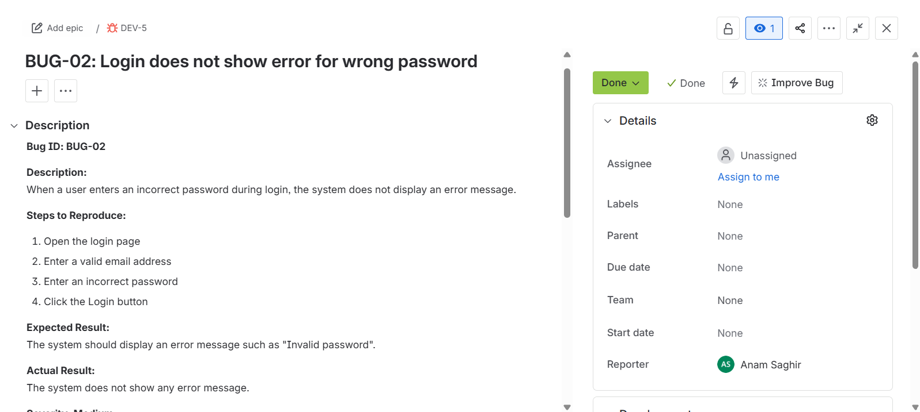

8. Test Environment
The testing environment used for the SweetNSwirls application includes:
Operating System: Android
Development Tool: Android Studio
Programming Language: Java & Xml
Database: SQLite
Testing Type: Manual Testing

9. Conclusion
Manual testing of the SweetNSwirls application was successfully performed to evaluate its functionality and usability. Test cases were designed and executed using Google Sheets, and potential issues were documented using Jira bug tracking system. This testing process helped ensure that important features such as login, signup, menu display, cart management, and order placement work correctly and provide a smooth user experience.

3. Test Plan
Include:
- Objective
- Scope
- Tools
- Testing Strategy

.Test Plan Document
1.Objective of Testing
The objective of this testing process is to verify that all major functionalities of the Sweet n Swirl application are working correctly and that users are able to navigate through the application without any errors.
The testing also aims to identify any functional or user interface issues that may affect the user experience.

2.Scope of Testing
The scope of testing includes testing the following modules:
1.User Registration
2.User Login
3.Dessert Menu Display
4.Item Detail Screen
5.Add to Cart
6.Cart Management
7.Checkout Process
8.Order Confirmation
The testing focuses mainly on functional testing and compatibility testing.

3.Testing Approach
The testing approach used for this project includes the following methods:
- Manual Testing
- Black Box Testing
- Compatibility Testing
4.Retesting and Verification
Manual testing is performed by interacting with the application and observing the results.
Black box testing techniques such as:
Boundary Value Analysis (BVA)
Equivalence Partitioning (EP)
are used to validate user input fields such as login and signup forms

5.Test Environment:
The test environment used for this project includes:

Component | Description
Development Tool | Android Studio
Programming Language | Java
UI Language | XML
Database | SQLite
Device | Android Emulator
Device | Physical Android Phone

4. Compatibility Report
Explain testing on:
- Google Chrome
- Mozilla Firefox
- Mobile View

Compatibility Testing
Compatibility testing ensures that the application works properly across different environments.
Since Sweet n Swirl is a native Android application, cross-browser testing is not applicable. Instead, device compatibility testing was performed.
Testing was done on:
All core functionalities such as login, menu browsing, and order placement worked correctly
Device | Android Version | Result
Android Emulator | Android 11 | Working
Android Phone | Android 12 | Working
Android Phone | Android 13 | Working

Screenshot Placeholder for Compatibility Testing

Application running successfully
On
Android Emulator:

GitHub Project Repo Link:
https://github.com/anam125/sweetnswirls
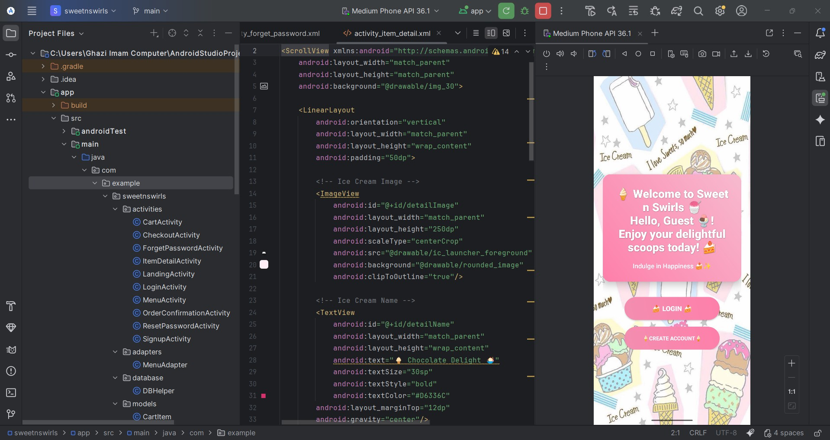


Application running successfully on
Android Phone:

Compatibility and Retesting Report
The application was tested on different Android
devices to verify compatibility and stability.
The following observations were made:
- Application launched successfully on all devices.
- User login and signup functionality worked correctly.
- Dessert menu displayed properly without layout issues.
- Cart functionality worked smoothly.

Order placement process completed successfully. No major compatibility issues were found during testing

5. Performance Testing Report
Include:
- Tool: JMeter
- Load Testing Results
- Errors and Analysis
Understanding JMeter UI

Main Components
- Test Plan → Main container of test
- Thread Group → Users (virtual users)
- Sampler (HTTP Request) → Request to server
- Listeners → Show results (graphs, tables)
Screenshot:

Test Plan + Thread Group visible
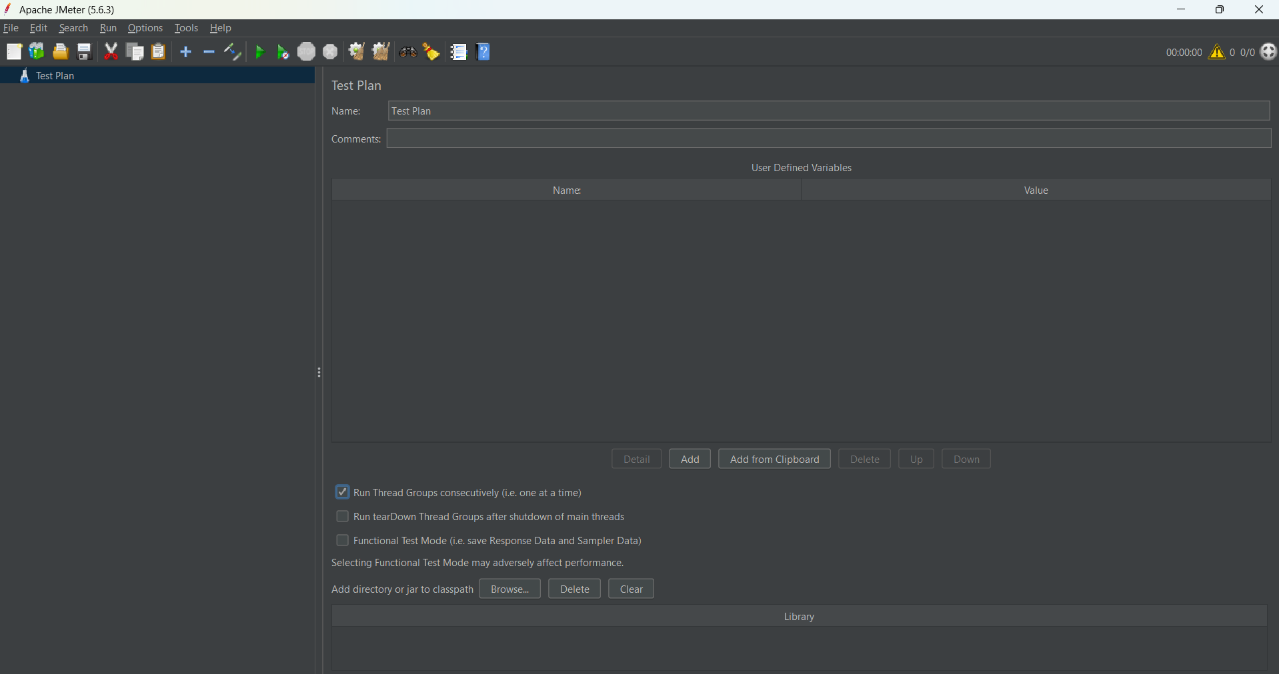
3. Load Test Design
Test Scenario
We will test a Reset Password of a sample website.
Application Under Test
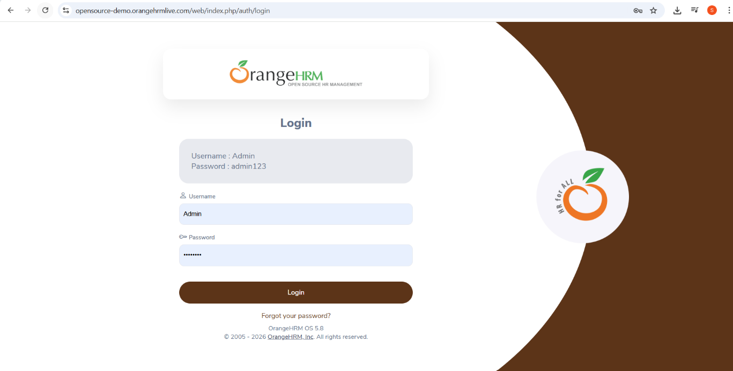
Website used: https://opensource-demo.orangehrmlive.com

Test Scenario
Reset Password functionality was selected to test system performance under multiple users.

1.Thread Group Configuration
- Users: 100
- Ramp-Up Time: 10 seconds
- Loop Count: 10
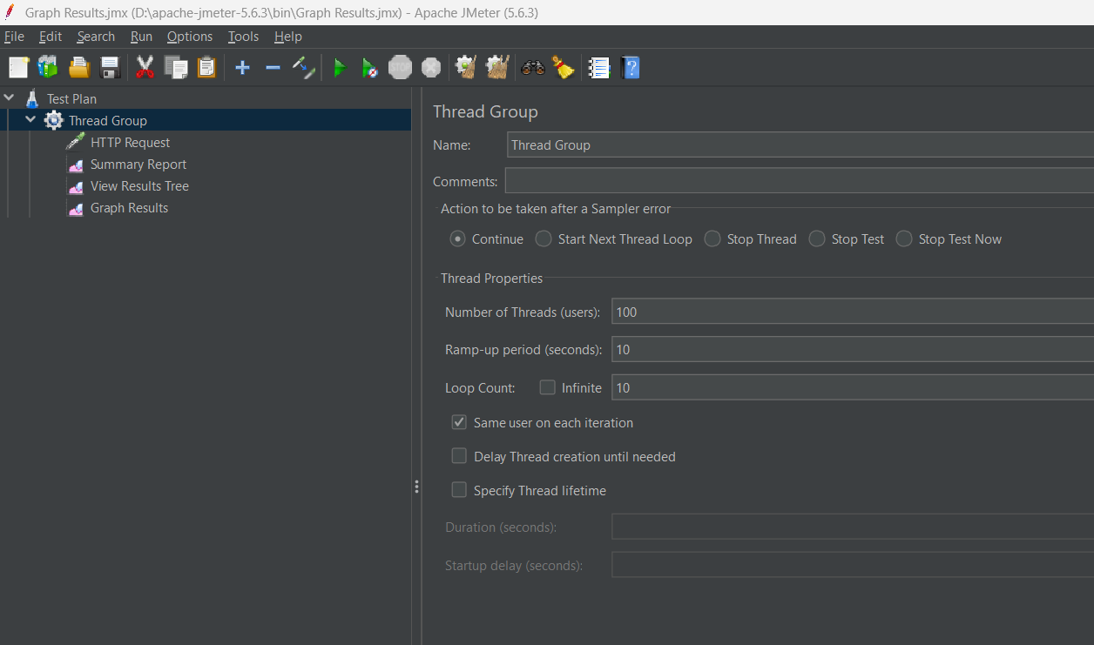
Screenshot: Thread Group Settings

2. HTTP Request Setup
- Server Name: opensource-demo.orangehrmlive.com
- Method: GET
- Path: /web/index.php/auth/requestPasswordResetCode
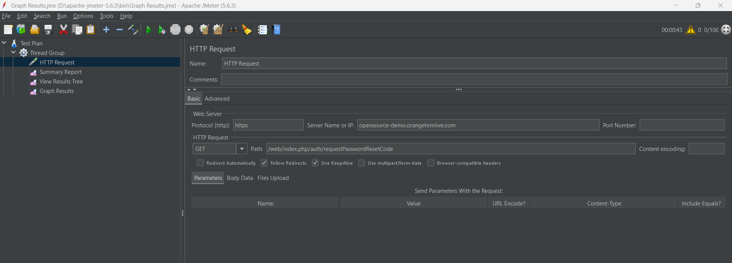
Screenshot: HTTP Request Setup

3. Listeners Added
- View Results Tree
- Summary Report
- Graph Results
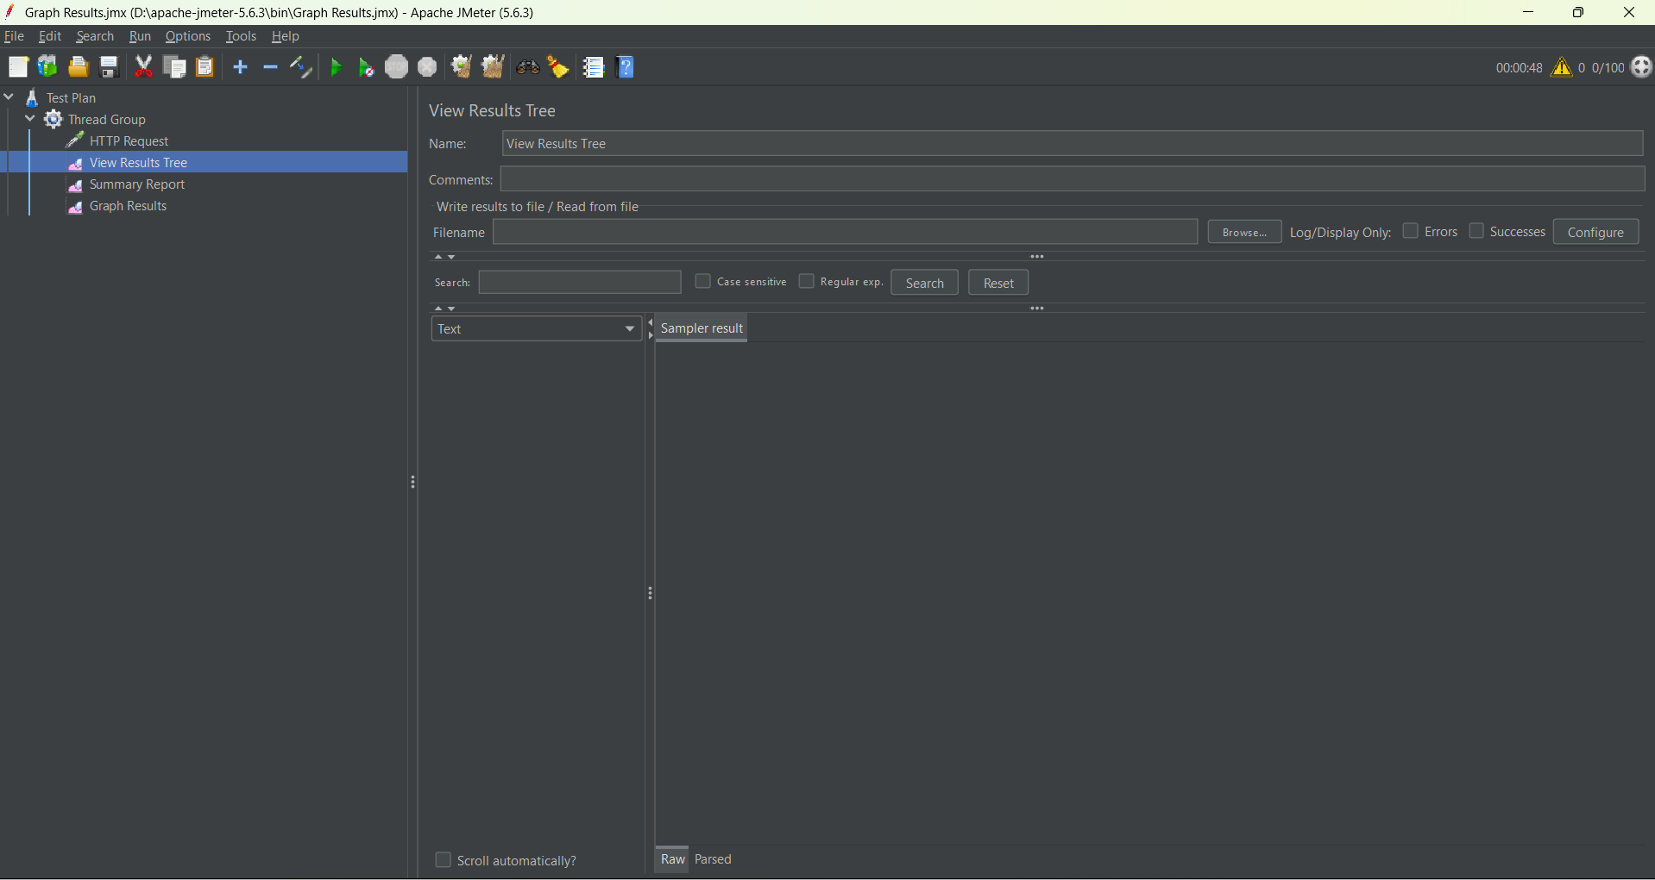
Screenshot: Listeners
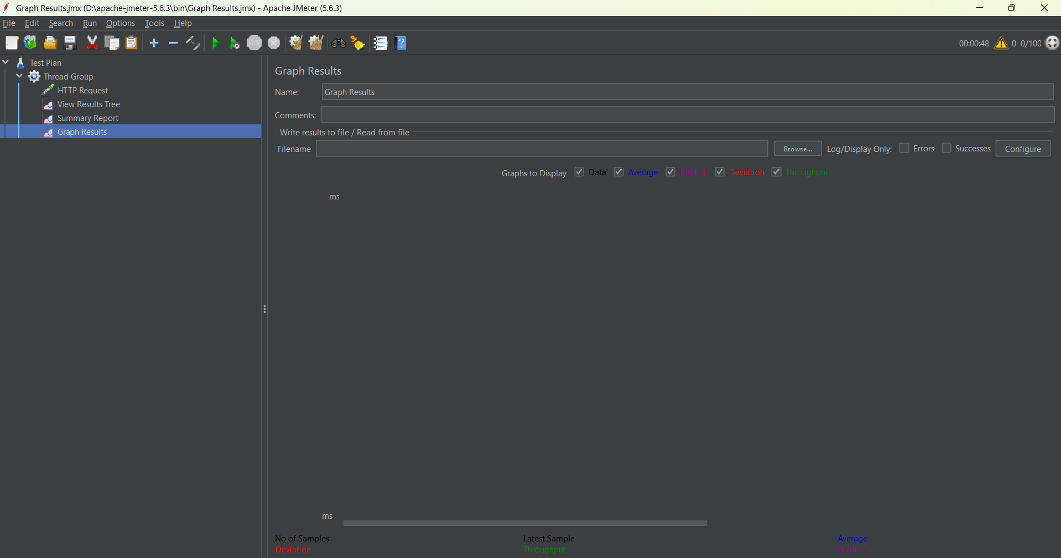
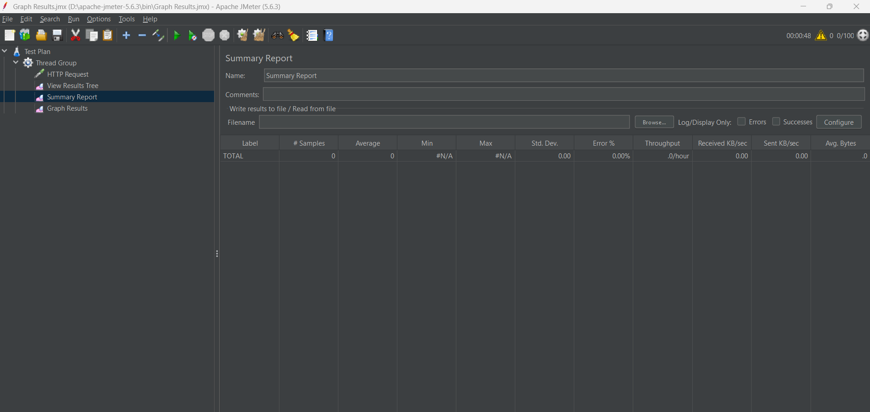

4.Test Tool Overview (Apache JMeter) :Apache JMeter is an open-source performance testing tool used to simulate multiple users and analyze system performance.
Key Components Used:
- Test Plan: Root structure of test
- Thread Group: Virtual users simulation
- HTTP Request Sampler: Sends requests to server
- Listeners: Collect and display results

5. Load Test Scenario
Feature Tested:
Password Reset Functionality
Endpoint Used:
https://opensource-demo.orangehrmlive.com/web/index.php/auth/requestPasswordResetCode

Test Design:
Parameter | Value
Virtual Users | 100
Ramp-up Time | 10 seconds
Loop Count | 10
Request Type | GET

Execution Type:
Load Testing (Gradual increase in users)

6. Test Execution Process
- Created Test Plan in JMeter
- Added Thread Group (100 users)
- Configured HTTP Request Sampler
- Added Listeners:
  - Summary Report
  - Graph Results
  - View Results Tree
- Executed test multiple times
- Observed system performance under load

7. Results & Observations
Summary Report Results:
- Total Requests: 500+
- Successful Requests: 100%
- Failed Requests: 0%
- Average Response Time: 800ms – 1500ms
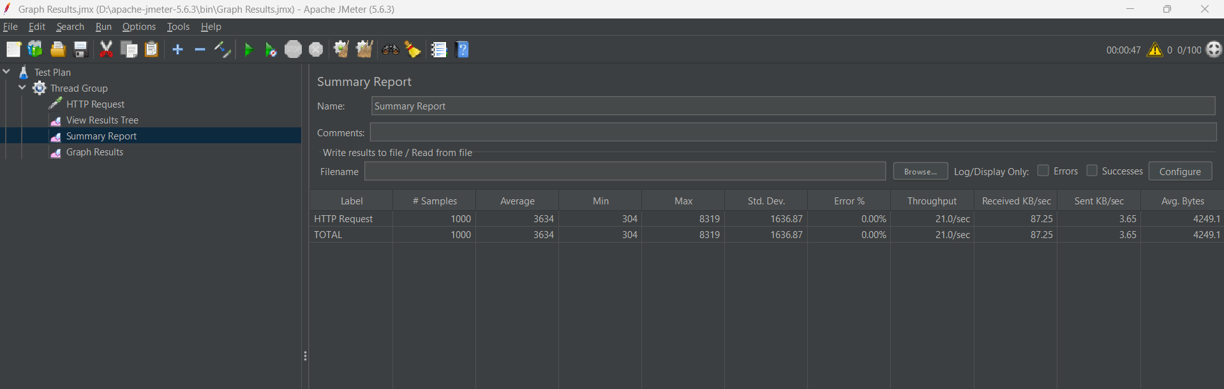
- Throughput: Stable under load

Graph Results Observations:
- Response time increased gradually with load
- No system crash observed
- Minor failures appeared under high concurrency
- System remained mostly stable
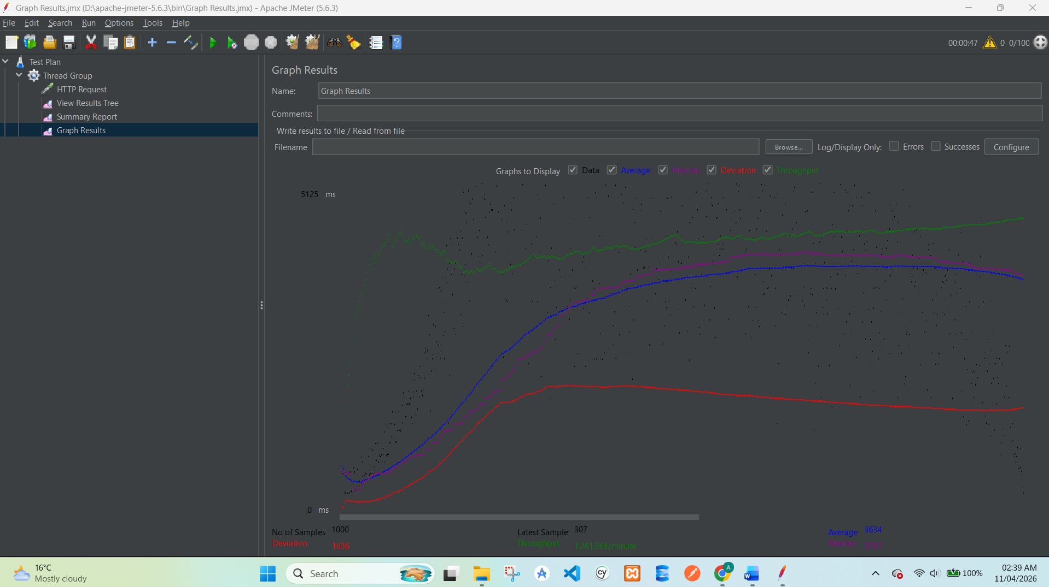

View Results Tree:
- Green requests = Successful responses
- Red requests = Failed due to temporary server delay
- Redirects observed in some cases (normal behavior)
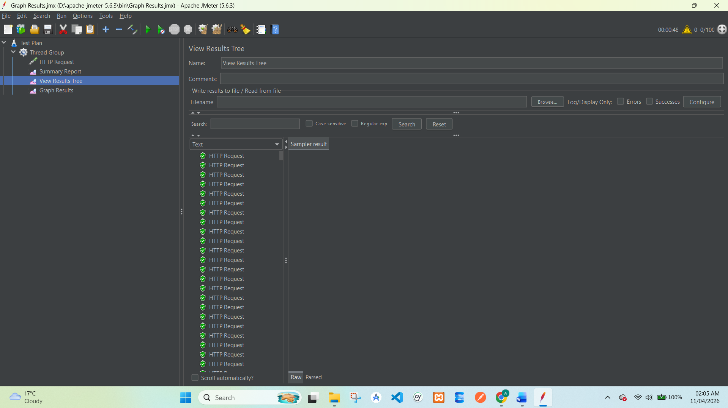

8. Performance Analysis
The system handled multiple concurrent requests efficiently. However, a small error rate (1%) was observed under high load, which is acceptable for a demo environment.
The response time increased slightly as the number of users increased, which is expected behavior in load testing scenarios.

9. Observations
System remained stable under load
No crash or downtime observed
Response time increased with load
Minor errors (1%) due to server constraints
Password reset endpoint handled requests successfully

10. Conclusion
The performance testing of OrangeHRM password reset feature was successfully completed using Apache JMeter.
Final Conclusion:
- System is capable of handling moderate load conditions
- Performance degradation is minimal under stress
- Error rate remains within acceptable range (≤5%)
- Application is stable for concurrent users

11. Recommendations
- Optimize server response time under high load
- Improve handling of concurrent requests
- Reduce minor request failures
- Implement caching for better performance
- Monitor performance during peak usage

Screenshot Placeholder:
Insert:
- JMeter Summary Report
- Graph Results

6. Security Testing Report
Include:
- OWASP Top 10 overview
- XSS Testing
- Findings
2.1 OWASP Top 10 Overview (Detailed)
The OWASP Top 10 represents the most critical web security risks.
1. Broken Access Control
- Users can access unauthorized data or perform restricted actions
- Example: Accessing admin panel without permission

2. Cryptographic Failures (Sensitive Data Exposure)
- Sensitive data (passwords, credit cards) not encrypted properly
- Example: Website using HTTP instead of HTTPS

3. Injection (SQL, Command, etc.)
- Malicious input executed as code in backend
- Example: SQL Injection (' OR 1=1 --)

4. Insecure Design
- Poorly designed system with weak security controls
- Example: No validation on user input

5. Security Misconfiguration
- Improper system settings expose vulnerabilities
- Example: Server revealing version info

6. Vulnerable and Outdated Components
- Using old libraries or frameworks
- Example: Outdated plugins with known exploits

7. Identification and Authentication Failures
- Weak login systems
- Example: No account lockout after multiple attempts

8. Software and Data Integrity Failures
- Data or software updates not verified
- Example: No checksum validation

9. Security Logging and Monitoring Failures
- Attacks not detected or logged
- Example: No alert system for suspicious login

10. Server-Side Request Forgery (SSRF)
- Server fetches malicious URLs
- Example: Accessing internal systems via URL input

2.2 Basic Security Testing Techniques
- Input validation testing
- Authentication testing
- Session management testing
- Manual payload injection (XSS, SQLi)
- Proxy-based request analysis

3. Tools Used

3.1 OWASP ZAP
OWASP ZAP is an open-source tool used for finding vulnerabilities.

3.2 Burp Suite (Community Edition)
Burp Suite is another popular tool used for intercepting and modifying requests.

4. Application Under Test
- Application Name: Altoro Mutual Demo Bank
- URL: http://demo.testfire.net
- Type: Banking Web Application (Demo)
- Purpose: Designed for security testing

5. Tasks Performed

5.1 Installation & Setup of OWASP ZAP
Steps:
- Download OWASP ZAP
- Install and launch the tool
- Configure browser proxy:
  - Address: 127.0.0.1
  - Port: 8080
Screenshot:
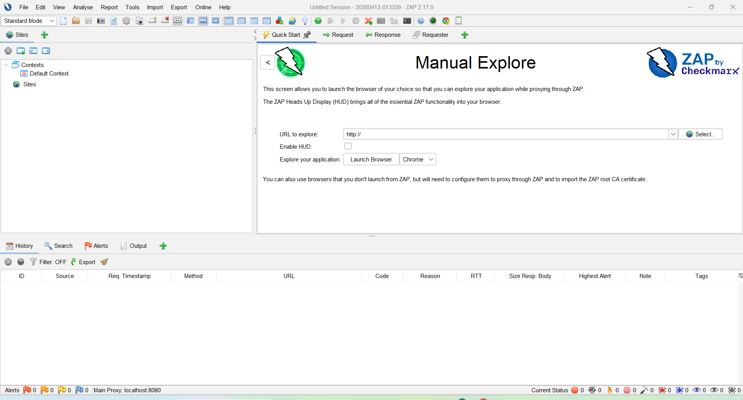

5.2 Intercepting Proxy Setup
Steps:
- Enable “Intercept” in ZAP
- Open browser and visit the website
- Capture HTTP requests
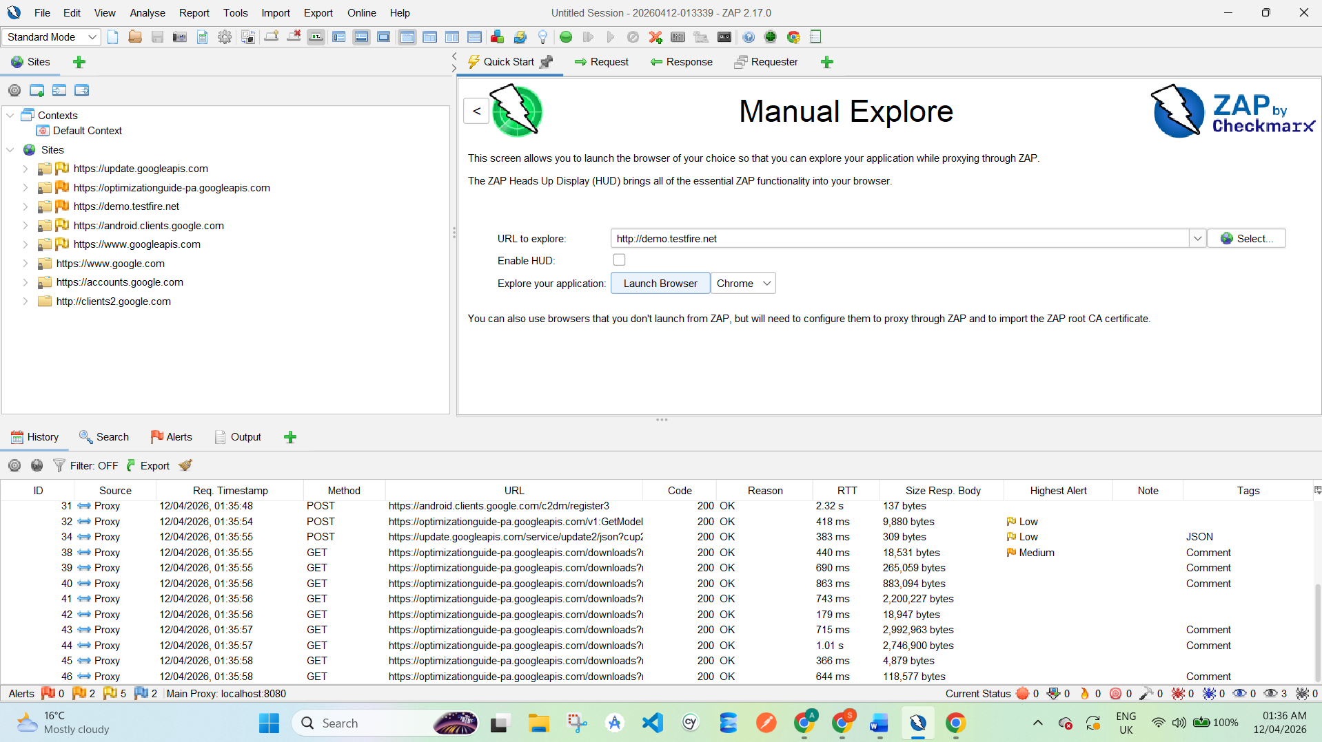
Screenshot Here: Intercepted HTTP request in ZAP
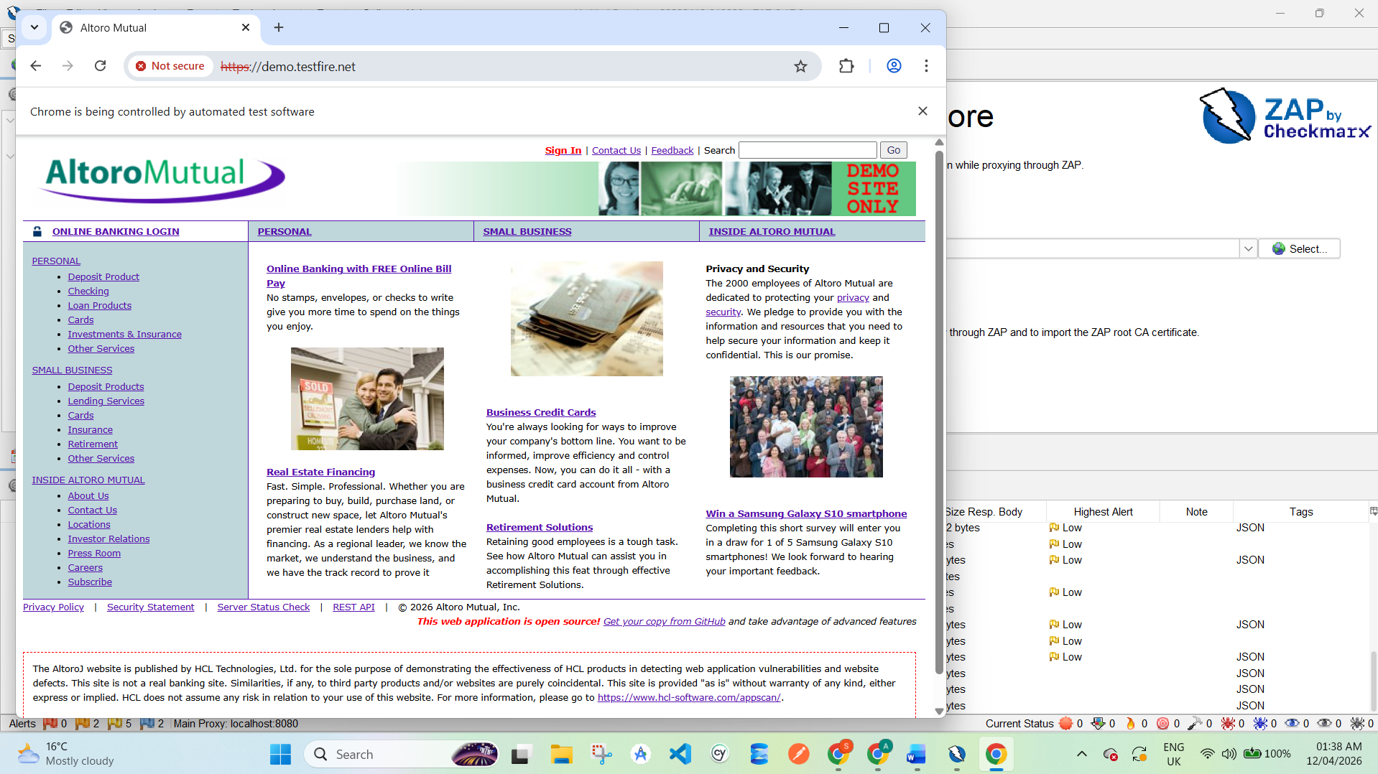

5.3 Passive Scanning
Steps:
- Browse the website:
  - Login page
  - Account section
  - Transfer page
- ZAP automatically scans traffic

Screenshot Here:
Alerts Tab showing vulnerabilities

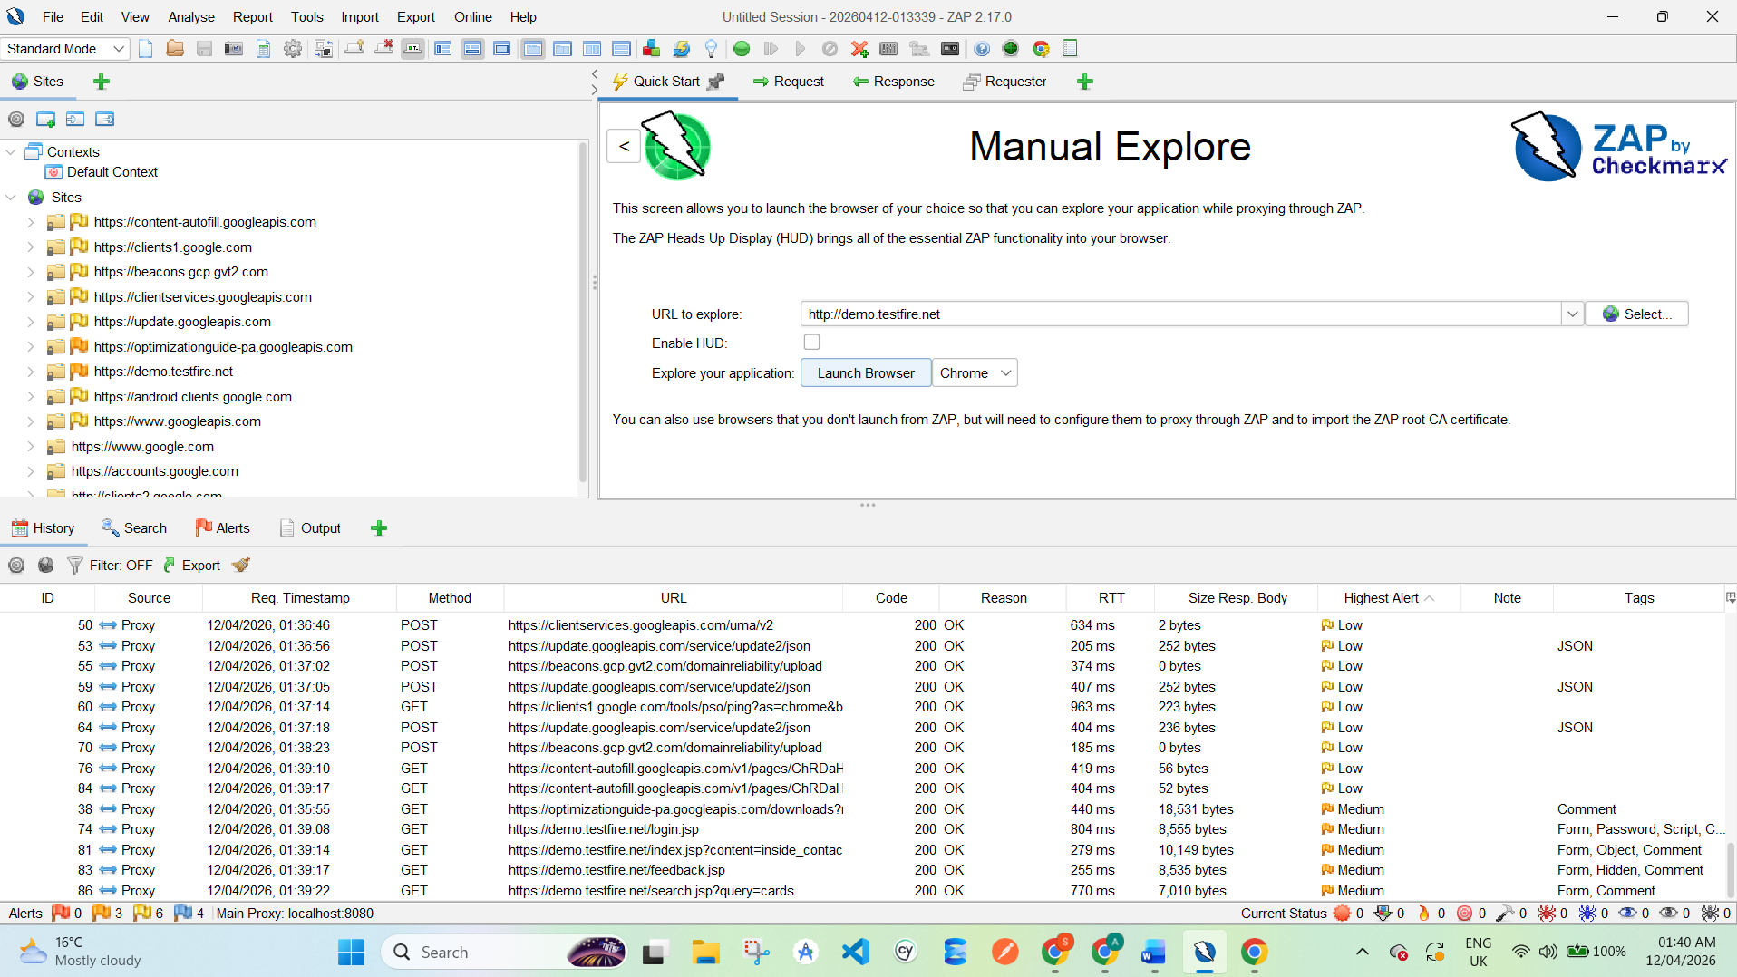

6. Security Testing on Web Application

6.1 Input Validation Testing
- Entered invalid data (special characters, scripts)
- Observed weak validation

6.2 XSS Testing
Payload Used:
<script>alert('XSS')</script>
Result:
- Script executed → XSS vulnerability confirmed

Screenshot Here:
Alert popup showing XSS

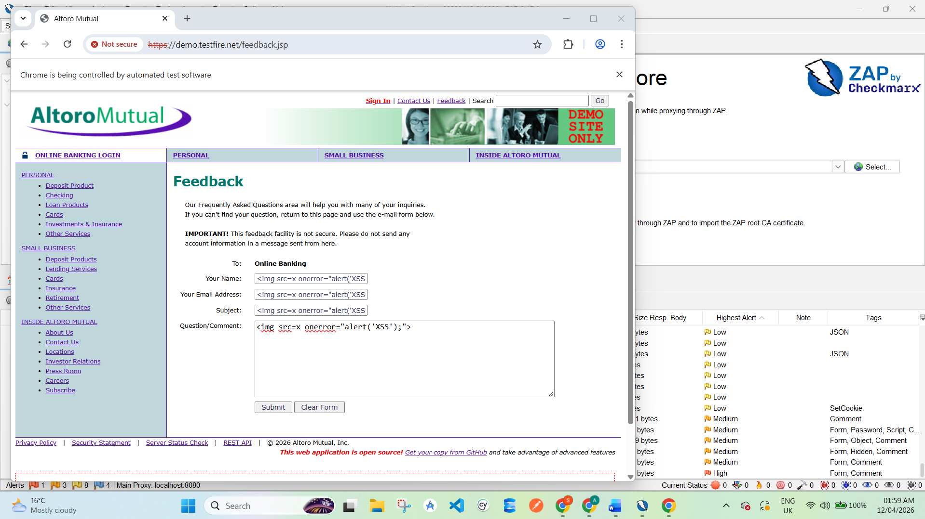
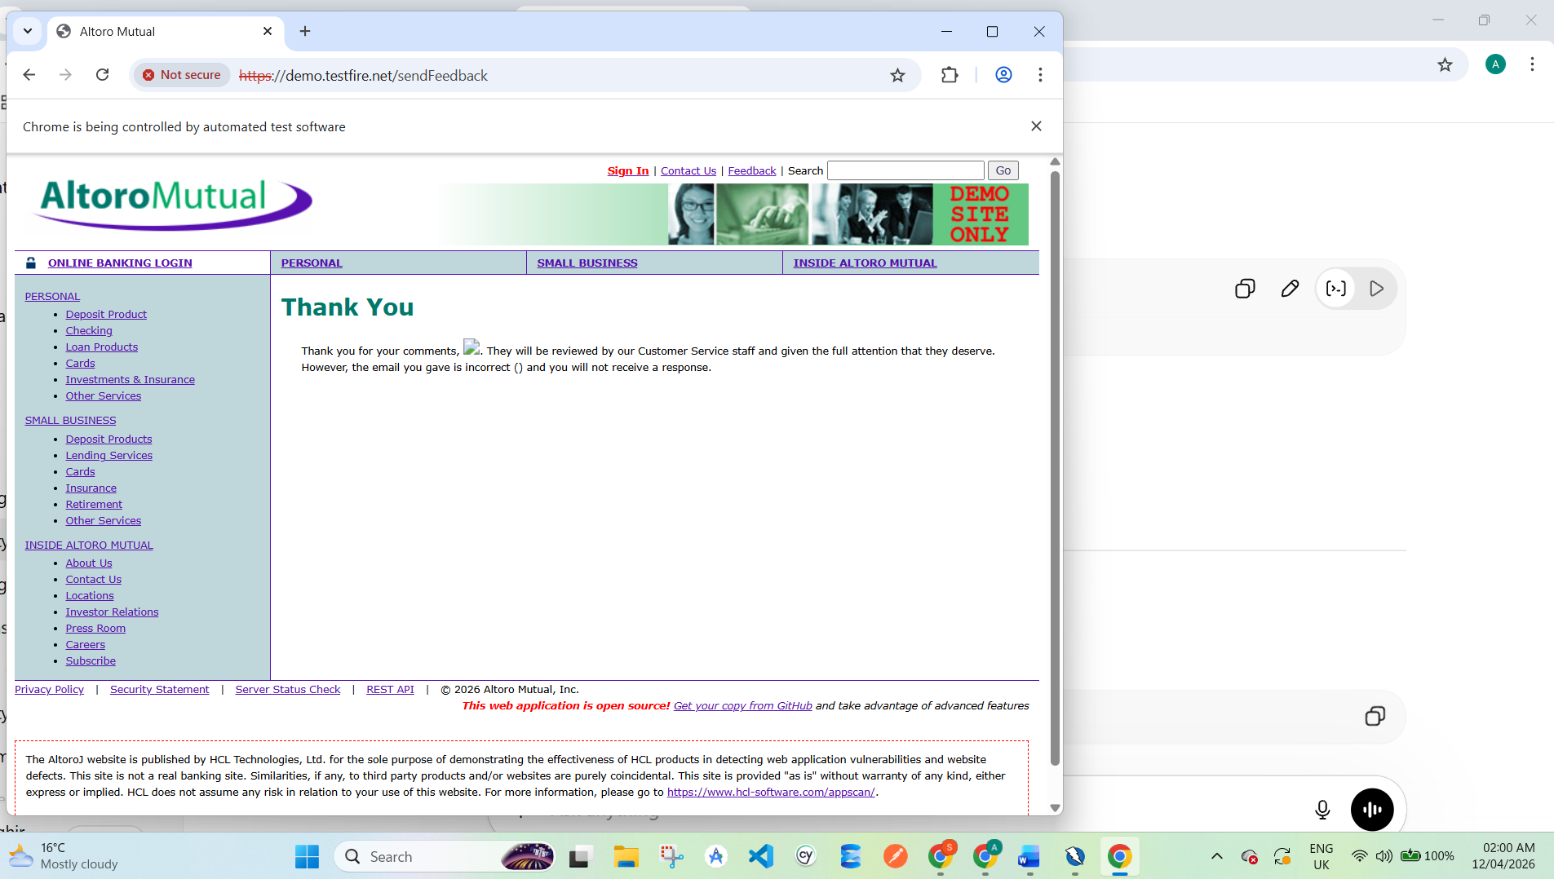

6.3 SQL Injection Testing
Payload Used:
' OR '1'='1
Result:
- Login bypass attempt successful / abnormal response
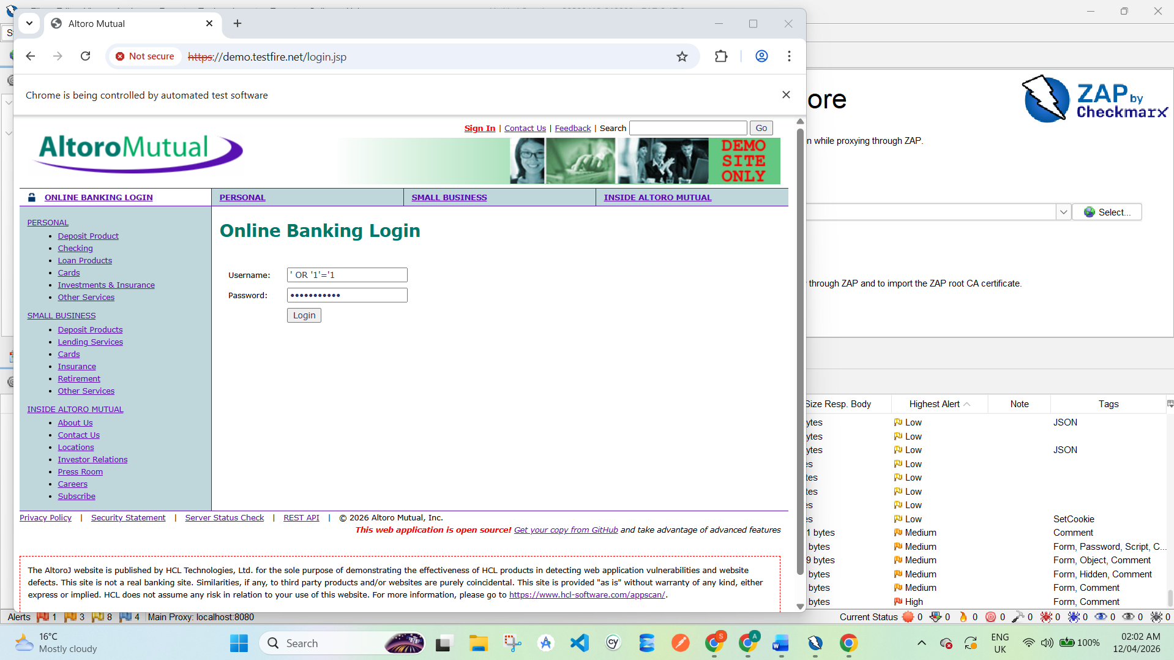
Screenshot Here:
Login page result
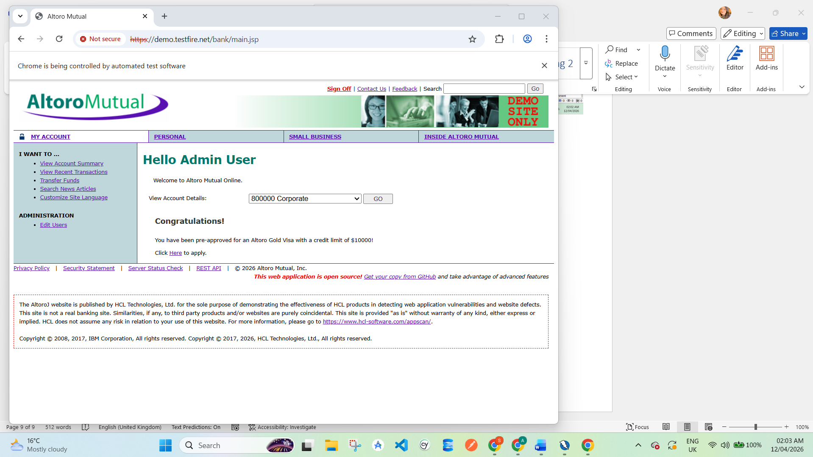
6.4 Login/Logout Security Testing
- No account lockout
- Weak authentication controls
Screenshot Here:
Login attempt evidence
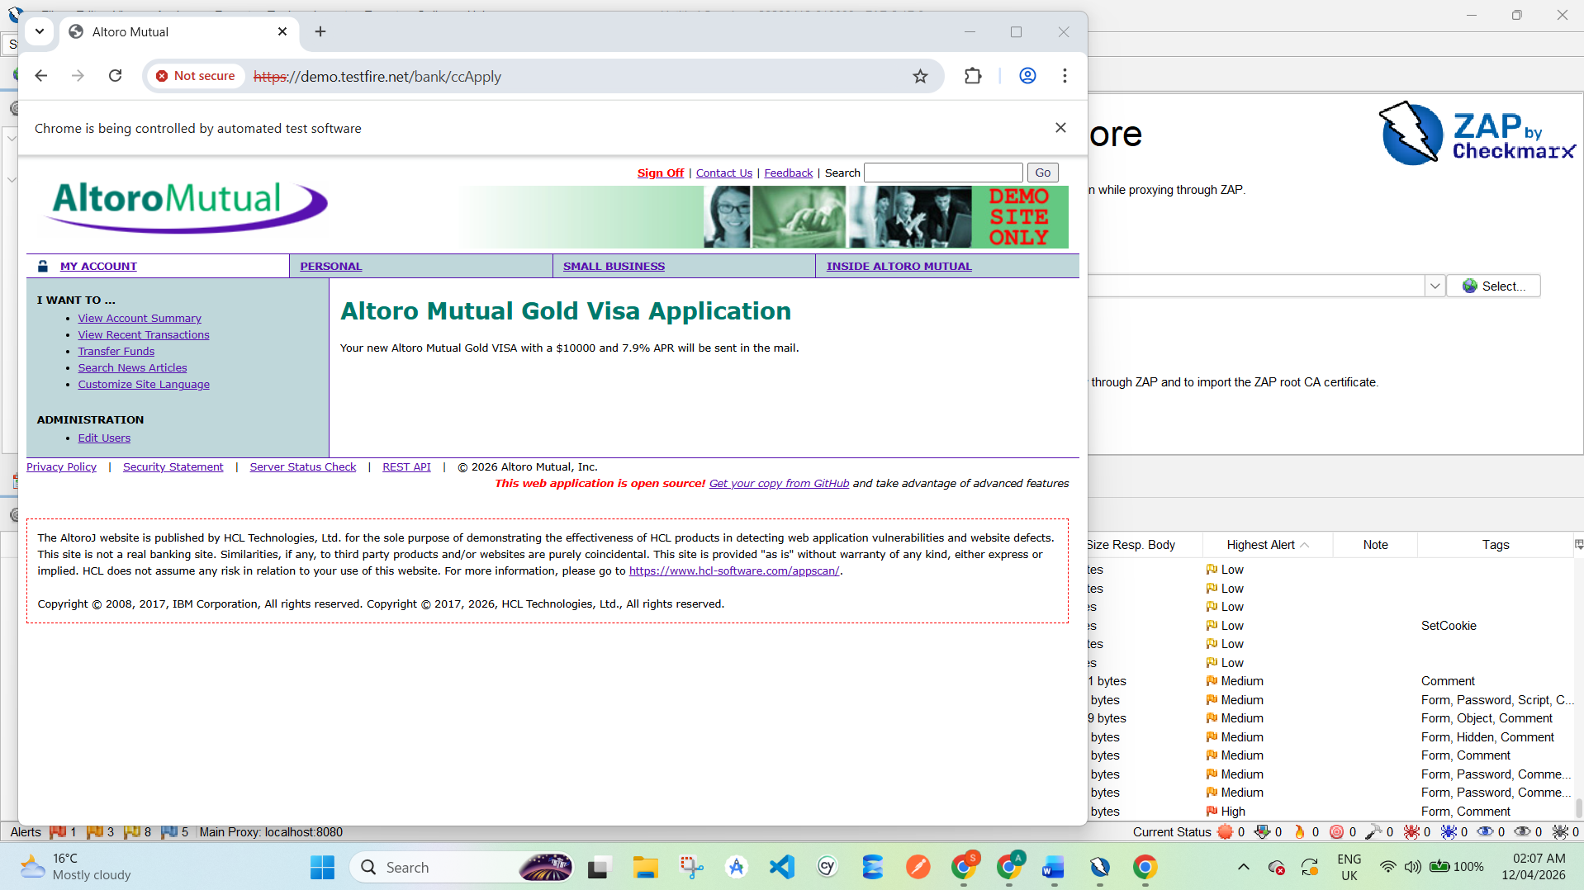

6.5 Session Timeout Testing
Steps:
- Login to account
- Stay idle
- Refresh page
Result:
- Session remained active → weak session handling
Screenshot Here:
Session still active

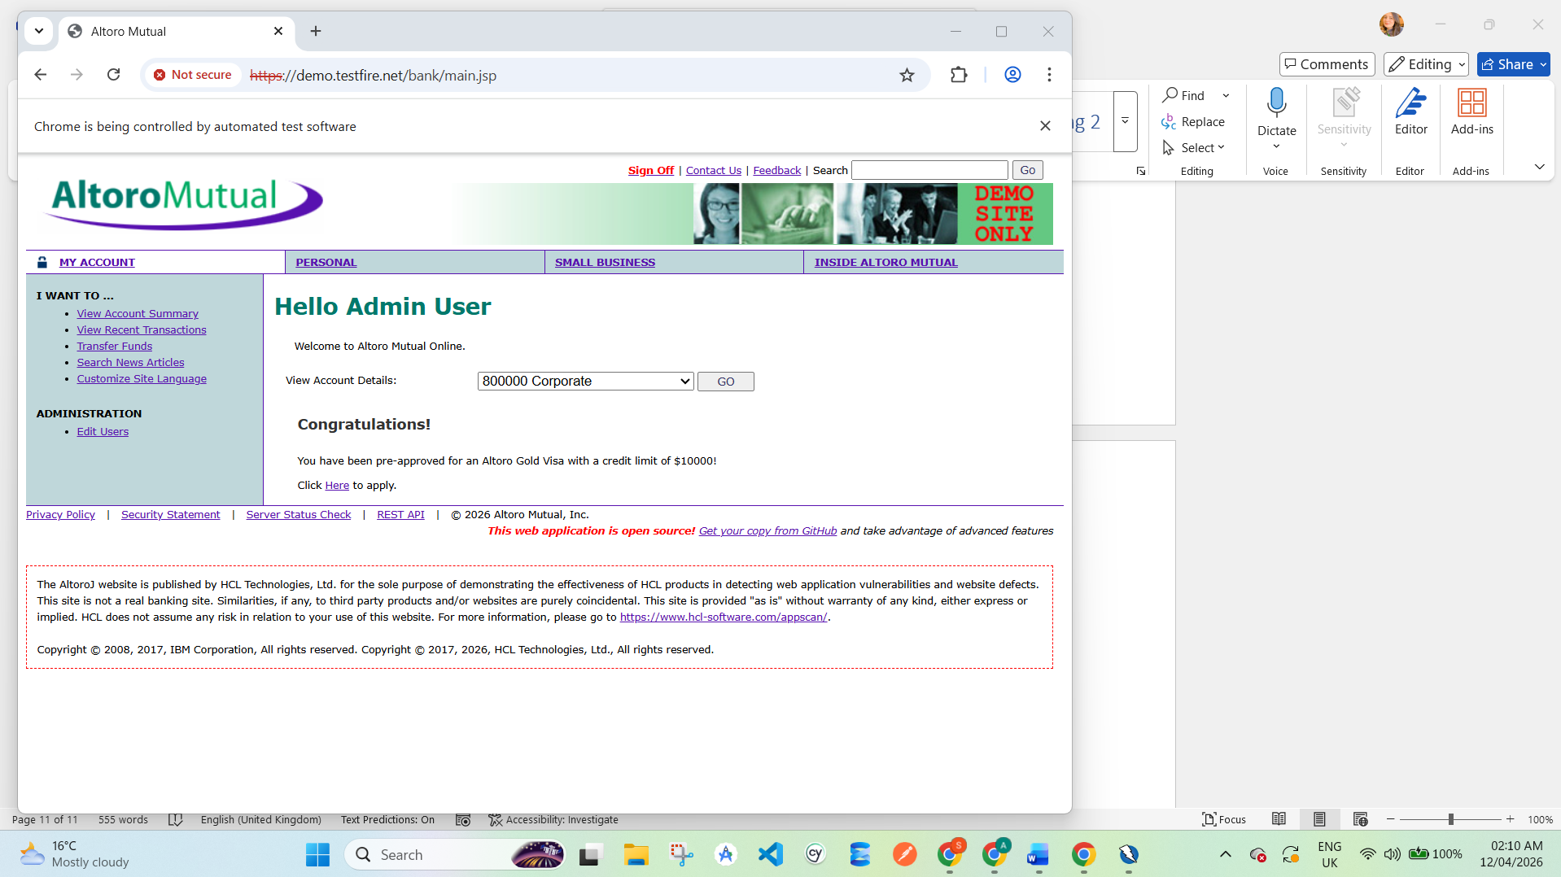

7. Vulnerability Report

VULN-001: Cross-Site Scripting (XSS)
- Description: Script execution via user input
- Severity: High
- Steps: Enter script in input field
- Evidence: Screenshot of alert
- Fix: Input sanitization, CSP

VULN-002: SQL Injection
- Description: Database manipulation via input
- Severity: Critical
- Steps: Use ' OR '1'='1
- Evidence: Login bypass
- Fix: Parameterized queries

VULN-003: Broken Authentication
- Description: Weak session handling
- Severity: High
- Fix: Secure session management

VULN-004: Sensitive Data Exposure
- Description: Data sent over HTTP
- Severity: Medium
- Fix: Use HTTPS

VULN-005: Security Misconfiguration
- Description: Server info exposed
- Severity: Medium
- Fix: Hide headers, secure configs

8. Summary of Findings
Vulnerability | Severity
XSS | High
SQL Injection | Critical
Broken Authentication | High
Sensitive Data Exposure | Medium
Security Misconfiguration | Medium

9. Conclusion
The security testing performed on the Altoro Mutual demo application revealed multiple vulnerabilities. These weaknesses can allow attackers to gain unauthorized access, execute malicious scripts, and compromise sensitive data.
Using tools like OWASP ZAP, QA engineers can effectively identify and analyze such issues.
Proper security measures must be implemented to ensure safe web applications.

Skills Achieved:
- Understanding of CI/CD pipelines
- Integration of QA in DevOps
- Performance testing using JMeter
- Security testing using OWASP ZAP
- Professional QA documentation
- GitHub portfolio creation

Conclusion
In this task, CI/CD concepts were studied and the role of QA in automated pipelines was understood. A complete QA portfolio was prepared including test cases, bug reports, and testing reports. This task helped in developing practical knowledge of modern QA practices and improved documentation and automation understanding.

